



SeeTrack CoPilot

User Manual

EULA for End-user Reference – as Accepted at Installation

SOFTWARE LICENSE AGREEMENT: SEETRACK COPILOT

1. LICENSE CONDITION:

SeeByte Limited, a company incorporated in Scotland with registered number SC194014 and having its registered office at Orchard Brae House, 30 Queensferry Road, Edinburgh EH4 2HS, Scotland (“SeeByte”) is willing to license you to use the software which accompanies this License Agreement (“Software”) upon the condition that you accept all of the terms contained in this License Agreement (“Agreement”). Please read the terms of this Agreement carefully before continuing installation, as pressing the "ACCEPT" button at the end of this Agreement will confirm your assent. If you do not agree to these terms, then SeeByte is unwilling to license the Software to you; so please press the "DECLINE" button to exit install. You may then return the full Software product with proof of purchase either to SeeByte or to the dealer from whom it was acquired, within sixty days of purchase, and your money will be refunded.

1. LICENSE AND WARRANTY:

You acknowledge and agree that the Software is the property of SeeByte (and/or its licensors, as the case may be) and is protected by copyright law in your country. While SeeByte continues to own the Software, you will have certain rights to use the Software after your acceptance of this Agreement. Except as may be modified by a license addendum which accompanies this Agreement, your rights and obligations with respect to the use of this Software are as follows:

***YOU MAY:***

(i) install and use one copy of the Software on a single computer only; and

(ii) make one copy of the Software Media prior to installation for back-up purposes, or copy the Software Media prior to installation onto the hard disk of your computer and retain the original for back-up purposes; and/or

(iii) use the Software on a network, provided that you have a licensed copy of the Software for each computer that can access the Software over that network;

***YOU MAY NOT:***

(iv) use the Software on more than one computer at any time (unless clause 2 (iii) above applies); or

(v) copy or otherwise replicate the Software (unless clause 2(ii) above applies), or copy or otherwise replicate the documentation which accompanies the Software; or

(vi) sublicense, rent or lease any portion of the Software; or

(vii) otherwise than as permitted by law, reverse engineer, decompile, disassemble, modify, translate, make any attempt to discover the source code of the Software, or create derivative works from the Software; or

(viii) use a previous version or copy of the Software after you have received a replacement or an upgraded version as a replacement of the prior version (any version upgrades provided under a maintenance or upgrade agreement or labeled ‘upgrade’ constitute part of the original license and not a second or additional license); or

(ix) sell or pass on any rights to this license to a third party, without the express prior written approval of SeeByte.

1. SIXTY DAY MONEY BACK GUARANTEE:

If you are the original licensee of this copy of the Software and are dissatisfied with it for any reason, you may return the complete Software product, together with your receipt, to SeeByte Limited or an authorized dealer, postage prepaid, for a full refund at any time during the sixty day period following the delivery to you of the Software.

1. LIMITED WARRANTY:

SeeByte warrants that the media on which the Software is distributed will be free from defects for a period of sixty (60) days from the date of delivery of the Software to you. Your sole remedy in the event of a breach of this warranty will be that SeeByte will, at its discretion, either replace any defective media returned to SeeByte within the warranty period, or refund the money you paid for the Software. SeeByte Limited does not warrant either expressly or impliedly that the Software will meet your requirements or that operation of the Software will be uninterrupted or that the Software will be error-free.

The above warranty is exclusive and in lieu of all other warranties, whether express or implied, including the implied warranties of merchantability, fitness for a particular purpose and non-infringement. This warranty gives you specific legal rights. You may have other rights, which vary from country to country or from state to state.

1. LIMITATION OF LIABILITY FOR DAMAGES:

Regardless of whether any remedy set forth herein fails of its essential purpose, in no event will SeeByte be liable to you for any special, consequential, indirect or similar damages, including any lost profits or lost data arising out of the use or inability to use the Software even if SeeByte has been advised of the possibility of such damages.

Some countries or states do not allow the limitation or exclusion of liability for incidental or consequential damages so the above limitation or exclusion may not apply to you.

In no case shall SeeByte's liability exceed the purchase price for the Software. The disclaimers and limitations set forth above will apply regardless of whether you accept the Software.

1. VALIDITY OF LICENSE:

This Agreement is not binding until the Software has been paid for in full and you have accepted the terms of the Agreement. However the 60 day period referred to in clauses 1, 3 and 4 above starts from the day the Software is supplied to you.

1. MAINTENANCE:

Maintenance and upgrades for the Software are available from SeeByte on the basis of specific additional commercial terms offered by SeeByte, as may be amended from time to time. If you decide to purchase such maintenance and/or support, but thereafter allow it to lapse, SeeByte reserves the right to charge a reinstatement fee in addition to the then applicable maintenance and/or upgrade charges in order to re-enable these services.

1. MODIFICATIONS: and TRANSFER OF AGREEMENT: and IMPROVEMENTS:

**Modifications**

SeeByte reserves the right at any time and from time to time to update, revise, supplement, and otherwise modify this Agreement and thereby impose new terms or conditions on your use of the Software. Such additional terms will be effective immediately upon notice of the same being given to you. Your continued use of the Software will be deemed to constitute your acceptance of any and all such new terms. All additional terms are hereby incorporated into this Agreement by this reference.

**Transfer of Agreement**

SeeByte shall be entitled to transfer, sub-licence and/or assign any of its rights and obligations under this Agreement. This will not affect your rights under this Agreement.

You may not transfer, sub-licence or assign any of your rights or obligations under this Agreement without SeeByte’s prior written consent.

**Improvements**

If you have comments on this Software or ideas on how to improve it, please contact us at: [offshore.support@seebyte.com](mailto:offshore.support@seebyte.com). Please note that by doing so, you also grant to us and third parties permission to use and incorporate your ideas or comments into our Software (or third party software) without further compensation.

1. TERM and TERMINATION: and CONSEQUENCES OF TERMINATION:

**Term**

The Agreement shall commence on your acceptance of the terms of the Agreement by pressing the “ACCEPT” button below. Thereafter, unless terminated as provided for below, the Agreement shall continue for so long as you comply with its terms.

**Termination**

SeeByte may terminate this Agreement at any time on written notice to you if you:

1. fail to comply with your obligations under this Agreement; or
2. are unable to pay your debts (within the meaning of section 123 of the Insolvency Act 1986 or equivalent legislation in your jurisdiction); or become insolvent; or, being a company or corporation, become subject to an order or a resolution for liquidation, administration, winding-up or dissolution (otherwise than for the purposes of a solvent amalgamation or reconstruction); or have an administrative or other receiver, manager, trustee, liquidator, administrator or similar officer appointed over all or any substantial part of your assets; or enter into or propose any composition or arrangement with your creditors generally; or are subject to any analogous event or proceeding in any applicable jurisdiction.

If you wish to terminate this Agreement, you should:

* notify us in writing at [offshore.support@seebyte.com](mailto:offshore.support@seebyte.com); and
* immediately cease using the Software and follow the uninstall instructions.

Where an annual licence fee is payable by you for use of the Software, you should provide us with written notice of your wish to terminate at least 30 days before the next annual licence fee is due to be paid, otherwise you will be liable to pay the next annual licence fee to SeeByte.

**Consequences of termination**

On termination of this Agreement (howsoever occasioned), you must:

* delete the Software from all of your computers, servers, devices and any other storage places and destroy all copies of the Software, documentation, modifications, enhancements and corrections then in your possession;
* pay any outstanding sums due to SeeByte (or its commercial partner)
* confirm to SeeByte in writing that you will not seek to develop, market or commercialise any software programs which are functionally equivalent to or otherwise competing with the Software (whether by copying or adapting the whole or any part of the Software, or otherwise) at any time within five years after termination of this Agreement; and

if asked to do so following termination, certify in writing to SeeByte that the Software and related materials have been so destroyed.

1. THIRD PARTY SOFTWARE:

If the Software as licensed under this Agreement contains any software provided by third parties, such third party software is provided without warranty by SeeByte and its use is and shall be subject to such third party licence conditions as may apply. For the HASP security software licensed to SeeByte by Aladdin Knowledge Systems (which contains the OpenSSL Toolkit), the applicable third party licence conditions are set out in Exhibit A and Exhibit B below.

1. GOVERNING LAW:

The terms of this Agreement shall be governed by and construed in accordance with Scots Law and you and SeeByte hereby agree to the non-exclusive jurisdiction of the Scottish Courts. You are solely responsible for compliance with any applicable laws of the country from which you use or otherwise access the Software

Document issue: v2.0, December 2008

**Exhibit A**

Open SSL License

A. **Notices**

1. Copyright (c) 1998-2005 The OpenSSL Project. All rights reserved.
2. Redistributions of source code must retain the above copyright notice, this list of conditions and the following disclaimer.
3. Redistributions in binary form must reproduce the above copyright notice, this list of conditions and the following disclaimer in the documentation and/or other materials provided with the distribution.
4. All advertising materials mentioning features or use of this software must display the following acknowledgment: “This product includes software developed by the OpenSSL Project for use in the OpenSSL Toolkit. (http://www.openssl.org/)”
5. The names "OpenSSL Toolkit" and "OpenSSL Project" must not be used to endorse or promote products derived from this software without prior written permission. For written permission, please contact openssl-core@openssl.org.
6. Products derived from this software may not be called "OpenSSL" nor may "OpenSSL" appear in their names without prior written permission of the OpenSSL Project.
7. Redistributions of any form whatsoever must retain the following acknowledgment: "This product includes software developed by the OpenSSL Project for use in the OpenSSL Toolkit (<http://www.openssl.org/>)"

B. **DISCLAIMER OF WARRANTY**

THIS SOFTWARE IS PROVIDED BY THE OpenSSL PROJECT ``AS IS'' AND ANY EXPRESSED OR IMPLIED WARRANTIES, INCLUDING, BUT NOT LIMITED TO, THE IMPLIED WARRANTIES OF MERCHANTABILITY AND FITNESS FOR A PARTICULAR PURPOSE ARE DISCLAIMED. IN NO EVENT SHALL THE OpenSSL PROJECT ORITS CONTRIBUTORS BE LIABLE FOR ANY DIRECT, INDIRECT, INCIDENTAL, SPECIAL, EXEMPLARY, OR CONSEQUENTIAL DAMAGES (INCLUDING, BUT NOT LIMITED TO, PROCUREMENT OF SUBSTITUTE GOODS OR SERVICES; LOSS OF USE, DATA, OR PROFITS; OR BUSINESS INTERRUPTION) HOWEVER CAUSED AND ON ANY THEORY OF LIABILITY, WHETHER IN CONTRACT, STRICT LIABILITY, OR TORT (INCLUDING NEGLIGENCE OR OTHERWISE) ARISING IN ANY WAY OUT OF THE USE OF THIS SOFTWARE, EVEN IF ADVISED OF THE POSSIBILITY OF SUCH DAMAGE.

**Exhibit B**

Original SSLeay License

A. **Notices**

1. Copyright (C) 1995-1998 Eric Young (eay@cryptsoft.com). All rights reserved.
2. This package is an SSL implementation written by Eric Young (eay@cryptsoft.com).
3. The implementation was written so as to conform with Netscapes SSL.
4. This library is free for commercial and non-commercial use as long as the following conditions are adheared to. The following conditions apply to all code found in this distribution, be it the RC4, RSA, lhash, DES, etc., code; not just the SSL code. The SSL documentation included with this distribution is covered by the same copyright terms except that the holder is Tim Hudson (tjh@cryptsoft.com).
5. Copyright remains Eric Young's, and as such any Copyright notices in the code are not to be removed.
6. If this package is used in a product, Eric Young should be given attribution as the author of the parts of the library used.
7. This can be in the form of a textual message at program startup or in documentation (online or textual) provided with the package.
8. Redistributions of source code must retain the above copyright notice, this list of conditions and the following disclaimer.
9. Redistributions in binary form must reproduce the above copyright notice, this list of conditions and the following disclaimer in the documentation and/or other materials provided with the distribution.
10. All advertising materials mentioning features or use of this software must display the following acknowledgment: "This product includes cryptographic software written by Eric Young (eay@cryptsoft.com)".
11. If you include any Windows specific code (or a derivative thereof) from the apps directory (application code) you must include an acknowledgement: "This product includes software written by Tim Hudson ([tjh@cryptsoft.com](mailto:tjh@cryptsoft.com))"

B. **DISCLAIMER OF WARRANTY**

THIS SOFTWARE IS PROVIDED BY ERIC YOUNG ``AS IS'' AND ANY EXPRESS OR IMPLIED WARRANTIES, INCLUDING, BUT NOT LIMITED TO, THE IMPLIED WARRANTIES OF MERCHANTABILITY AND FITNESS FOR A PARTICULAR PURPOSE ARE DISCLAIMED. IN NO EVENT SHALL THE AUTHOR OR CONTRIBUTORS BE LIABLE FOR ANY DIRECT, INDIRECT, INCIDENTAL, SPECIAL, EXEMPLARY, OR CONSEQUENTIAL DAMAGES (INCLUDING, BUT NOT LIMITED TO, PROCUREMENT OF SUBSTITUTE GOODS OR SERVICES; LOSS OF USE, DATA, OR PROFITS; OR BUSINESS INTERRUPTION) HOWEVER CAUSED AND ON ANY THEORY OF LIABILITY, WHETHER IN CONTRACT, STRICT LIABILITY, OR TORT (INCLUDING NEGLIGENCE OR OTHERWISE) ARISING IN ANY WAY OUT OF THE USE OF THIS SOFTWARE, EVEN IF ADVISED OF THE POSSIBILITY OF SUCH DAMAGE.

This document is issued in confidence for the purpose only for which it is supplied. It must not be reproduced in whole or in part or used for any purpose except an agreement or with the consent in writing of SeeByte Limited. No information as to the contents or subject matter of this document or any part thereof arising directly or indirectly there from shall be given orally or in writing or communicated in any manner whatsoever to any third party being an individual firm or company or any employee thereof without the prior consent of SeeByte Limited.

Table of Contents

Acronyms and Terminology 11

1 Using This Manual 13

1.1 Scope and Purpose 13

1.2 Targeted Audience 13

2 General Overview 13

2.1 Requirements 14

2.2 Dynamic Positioning System 14

2.3 SeeTrack CoPilot Core Features 14

3 Operation 15

3.1 Installation 15

3.2 First-time Installation 15

3.3 Checking and Running SeeTrack CoPilot 16

3.4 Interfacing SeeTrack CoPilot 17

3.4.1 Front Panel 17

3.4.2 Rear Panel 18

3.5 Hardware Specification 18

3.5.1 Front Panel Layout 18

3.5.2 Rear Panel Layout 19

3.5.3 Power 21

3.5.4 Emergency Stop Button 21

3.5.5 Communications 22

3.5.6 Display - Connection 23

3.6 Power Up/Down Procedures 23

3.6.1 Switching the SeeTrack CoPilot Hardware Unit On 23

3.6.2 Switching the SeeTrack CoPilot Hardware Unit Off 24

4 Pilot Interface Overview 24

5 Navigation Chart Display 25

5.1 Navigation Chart Display Zoom Scale Control 26

6 Water Column Display 26

6.1 Water Column Display Zoom Scale Control 28

7 Pilot Information Display 28

7.1 Navigation Information 28

7.2 Status Indicators 28

7.2.1 The DP Status Indicator 29

7.2.2 The Position Status Indicator 29

7.2.3 The Joystick Indicator 30

7.2.4 The Navigation Status Indicator 30

7.2.5 The DVL Lock Indicator 30

7.2.6 The External Position Fix Indicator 31

7.2.7 The Sonar Indicator 31

7.3 Markers 31

7.3.1 Placing a Marker at the Current Position 32

7.3.2 Manually Placing a Marker 32

7.3.3 Fly to Marker 33

7.3.4 Save Marker Positions 33

7.3.5 Load a Marker File 33

7.3.6 Editing Markers 34

7.3.7 Deleting a Marker 34

7.3.8 Selecting Multiple Markers for Deletion 34

7.4 Flight Modes 35

7.4.1 HOVER Command 35

7.4.2 Flying in MANUAL Mode 35

7.4.3 Flying in AUTOHOVER Mode 36

7.4.4 Flying in AUTOFLY Mode 36

7.4.5 Flying in CRUISE Mode 47

7.5 Velocity Controls 48

7.6 Single Axis Auto Modes 48

7.6.1 Auto-Heading 49

7.6.2 Auto-Depth 49

7.6.3 Auto-Altitude 49

7.7 Sonar 50

7.7.1 Reset Sonar Communications 50

7.7.2 Auto-Intensity On/Off 50

7.7.3 Intensity/Threshold 51

7.7.4 Colour map 51

7.7.5 Target Size Slider 51

7.7.6 Sonar View Range Sliders 51

7.8 Alarm Panel 52

7.9 Additional Functions 53

7.9.1 External Position Fix 53

7.9.2 Log Recording 54

7.9.3 Load Vector Chart 55

7.9.4 Clearing Breadcrumb Trail 56

7.10 Preferences 56

7.10.1 Units 56

7.10.2 Additional Features 57

7.10.3 System 59

7.10.4 Vehicle 63

7.10.5 About 64

7.11 Data Directory 64

8 Flying with Dynamic Positioning 65

9 Appendix A 68

9.1 Technical Specifications 68

10 Appendix B 70

10.1 Interface Box 70

10.2 Interface Box Front Panel Layout 70

10.3 Interface Box Rear Panel Layout 71

10.4 Operation 71

11 Appendix C 72

11.1 Example Scenario 72

Table of Figures

Figure 1 – Unit Installation onto Cabinet 15

Figure 2 –SEETRACK COPilot Interface Icon 16

FIGURE 3 – SEETRACK COPILOT INTERFACE OVERVIEW 17

Figure 4 – Interfacing the SeeTrack CoPilot unit Front Panel 17

Figure 5 – Interfacing the SeeTrack CoPilot unit Rear Panel 18

Figure 6 – SeeTrack CoPilot hardware unit Front Panel Layout 18

Figure *7* – Rear Panel layout 19

Figure 8 – Pin-out Details 23

Figure 9 – Pilot Interface Overview 25

Figure 10 – ROV Moving in Water Column Display 27

Figure 11 – navigation information 28

Figure 12 - Status Indicators 29

Figure 13 - DP running indicator 29

FIGURE 14 - DP STANDBY Indicator 29

Figure 15 - DP STANDBY DISPLAY 29

FIGURE 16 - IN POSITION INDICATOR 30

Figure 17 - Joystick indicator 30

Figure 18 – Nav Global Indicator 30

Figure 19 - NAV LOCAL INDICATOR 30

Figure 20 – Nav Fault Indicator 30

FIGURE 21 - DVL LOCK (loCK LOST) Indicator 31

FIGURE 22 – EXTERNAL POSITION FIX INDICATOR 31

FIGURE 23 – SONAR INDICATOR 31

Figure 24 - Marker Panel Interface 32

FIGURE 25 - MARK CURRENT LOCATION 32

FIGURE 26 - ADD MARKER 32

FIGURE 27 - ADDING A MARKER 32

FIGURE 28 - FLY TO MARKER 33

FIGURE 29 - SAVE MARKER LIST 33

Figure 30 - load marker list 33

Figure 31 - Load Marker window 34

Figure 32 - Delete Marker 34

Figure 33 – Flight Mode Buttons 35

Figure 34 – Navigation tool Buttons 37

Figure 35 – Waypoint Options 39

Figure 36 – Survey Plan Path 40

Figure 37 – Survey Plan Editor 41

Figure 38 – Survey Plan Buttons 42

Figure 39 – tracking display 43

Figure 40 – tracking A TARGET 44

Figure 41 – tracking A POINT 45

Figure 42 – tracking PANEL 45

Figure 43 – Velocity Control Buttons DEFINED AS FAST- MEDIUM AND SLOW 48

Figure 44 – SINGLE AXIS Auto Modes 48

Figure 45 - Reset sonar comms 50

Figure 46 - Enable / Disable Auto-Intensity 50

Figure 47 - Intensity and threshold sliders 51

Figure 48 - Target Size Slider 51

Figure 49 - Sonar Range Sliders 52

Figure 50 – Alarm Panel 53

Figure 51 - Additional interface functions 53

Figure 52 - Update Global Reference DIALOG 54

Figure 53 – Load Vector Chart 55

Figure 54 - Additional features 57

Figure 55 - Range and bearing tool 57

Figure 56 – Vehicle Trail 58

Figure 57 – Water Current Profile 58

Figure 58 – Water Current Display 59

Figure 59 - Vehicle chooser 60

Figure 60 – Joystick Calibration 60

Figure 61 – Deadband Settings 61

Figure 62 – Drivers Configuration 62

Figure 63 - Vehicle setup 63

Figure 64 – Control Axis 65

Figure 65 – Flying with DP 65

FIGURE 66 – TOLERANCE OVERVIEW 66

Figure 68 – Depth Tolerance Overview 67

Figure 69 – Connecting the ROV Interface Box to the unit 70

Figure 70 – Interface Box Front Panel Connectors 71

Figure 71 - Interface Box Rear Panel Connectors 71

**List of Tables**

Table 1 – Front Panel Connections 19

Table 2 – Rear Panel Connections 21

Table 3 – Pin-out Descriptions 23

Table 4 – navigation status indicators 30

Table 5 – Technical Specification 69

Table 6 – Interface Box Front Panel Connector Descriptions 71

Table 7 – Interface Box Rear Panel Connector Descriptions 71

Acronyms and Terminology

|  |  |
| --- | --- |
| **API** | Application Programming Interface |
| **DP** | Dynamic Positioning |
| **DVL** | Doppler Velocity Log |
| **IB** | Interface Box |
| **LED** | Light Emitting Diode |
| **ROV** | Remotely Operated Vehicle |
| **TMS** | Tether Management System |

|  |
| --- |
| **Distribution:**  **CUSTOMER** |

**Revision History**

|  |  |  |
| --- | --- | --- |
| **Revision** | **Date** | **Comment** |
| **01** | April 2007 | Ross Hall – Document Created |
| **02** | Jan 2009 | Emma Macphail – Updating Document |
| **03** | Jul 2010 | Nicole Irvine – Updating Document |
| **04** | Oct 2010 | Nicole Irvine – Editorial Checking |
| **05** | Dec 2013 | Lewis Deacon – Updating Entire Document |
| **06** | Jan 2014 | Nicole Irvine – Updating Branding |

Authors: Benjamin Privat

This document is commercial in confidence. If you have received it in error, please contact:

SeeByte

Registered in Scotland Number: SC194014

Registered Office: Orchard Brae House, Edinburgh, EH4 2HS

VAT Registration Number: 783656681

Tel: +44 (0) 131 447 4200

Fax: +44 (0) 131 447 4911

[www.seebyte.com](http://www.seebyte.com)

# Using This Manual

This user manual provides a general product overview and explains how to install and operate the SeeTrack CoPilot unit and its pilot interface.

All the documentation files are in Adobe® Portable Document Format (*.pdf). To view these files you must use Adobe® Reader® 8.0 or above. This program is installed on the SeeTrack CoPilot hardware unit.

**Note**: This manual should be used in conjunction with the other guides included in the SeeTrack CoPilot hardware unit.

## Scope and Purpose

This manual provides the following:

* an overview of the SeeTrack CoPilot hardware unit configuration and connectivity;
* a general description and specification of SeeTrack CoPilot pilot interface; and
* operating instructions for SeeTrack CoPilot and equipment.

## Targeted Audience

This manual is designed and developed for offshore operators and contractors who are required to operate remotely operated vehicle (ROV) systems using SeeTrack CoPilot.

# General Overview

SeeTrack CoPilot provides the latest generation of SMART software tools in a simple to use, pilot-friendly form. Training using SeeTrack CoPilot is painless and the intuitive tools help novice users.

SeeTrack CoPilot automates the ROV control process. The ROV can efficiently manoeuvre through a mission, automatically compensating for the effects of currents. The ROV can also take better quality video pictures due to the improved stability when using SeeTrack CoPilot.

SeeTrack CoPilot can be easily retro-fitted to operational units that are fitted with a DVL and a heading reference system.

Pilots using ROVs equipped with SeeTrack CoPilot will be able to:

* hold position and heading at the touch of a button;
* change the position and heading accurately using a simple point-and-click mouse interface;
* use the ROV joystick intuitively, without having to consider currents and tether effects;
* cruise at a constant speed and heading;
* generate accurate waypoint requests by entering specific coordinates;
* plan detailed missions by simply selecting a series of waypoints with the mouse;
* load a vector map of the area; and
* concentrate on the operations and not the action of piloting.

## Requirements

SeeTrack CoPilot requires that the ROV is equipped with a Doppler Velocity Log (DVL).

The addition of dead-reckoning sensors such as gyro, depth and altimeter will improve the overall stability and control of the ROV.

## Dynamic Positioning System

A dynamic positioning (DP) system allows an ROV to automatically hold a requested position. A DP system mimics automatically what a pilot would do in adjusting the thrusters to keep the desired position.

The pilot can easily control the ROV using the DP system. For example, if the pilot manoeuvres the joystick to the forwards position, the ROV will move forwards whilst automatically compensating for cross-currents and tether effects.

**Note**: Please refer to section 8 – for a more detailed explanation of the DP system.

## SeeTrack CoPilot Core Features

The core features of SeeTrack CoPilot are:

* **Pilot Interface**: The SeeTrack CoPilot pilot interface offers the visual aid of real-time monitoring. Its non-intrusive, dark background enhances the display on screen and allows the user to extract vital real-time information for piloting.
* **Hover Command**: This command provides station-keeping at the touch of a button.
* **Auto-hover Flight Mode**: In this mode the ROV switches automatically between MANUAL mode (when the joystick is in use) and HOVER (when the joystick is not in use).
* **Auto-fly Flight Mode:** In this mode the ROV can be controlled through the enhanced joystick velocity controller or through the Click & Go interface. This mode also enables the alternative navigation tools of the Survey and tracking Module.
* **Cruise Flight Mode**: In this mode the ROV can be made to move at a constant speed, depth/altitude and heading. The pilot can adjust position and heading without interrupting the flight.
* **Easy to Use Application Programming Interface (API)**: SeeTrack CoPilot API allows simple integration of new sensors.
* **Survey Module**: This core module comprises the additional navigation tools of Survey Plan and Waypoint, which allow the user to plan specific missions for the ROV with ease and precision.
* **Target Relative Control Module:** This tool works by using sonar input, analysing the images produced by the sonar and identifying targets within the sonar field of view. If a target has been selected, the user is able to reliably and safely move the vehicle relative to the target, provided it remains within the field of view of the sonar. The tracking module has applications in sub-sea operations, such as riser tracking, that allow the vehicle to easily maintain a constant visual of the selected target.

# Operation

The following section **must** be read carefully before installing and operating SeeTrack CoPilot.

## Installation

The SeeTrack CoPilot hardware unit should be removed carefully from its transit case and be checked for any damaged or missing parts. It should be placed in a rack mount cabinet or any other rack mount system.



Figure 1 – Unit Installation onto Cabinet

**Note**: In addition to the SeeTrack CoPilot unit, an interface box (IB) may be required, but only when using an analogue joystick interface. Refer to section 10.1 – for further details.

## First-time Installation

SeeByte personnel will complete the initial unit installation on-site as it involves a technical tuning phase.

The installation includes:

* ROV-specific hardware interface design;
* liaison with customer’s engineers;
* development of software interface; and
* on-site testing at customer’s base.

## Checking and Running SeeTrack CoPilot

The following steps are to ensure that the unit is working properly, and should be followed in order to start using the SeeTrack CoPilot unit.

The SeeTrack CoPilot unit should be firmly mounted onto a rack mount cabinet. The software is pre-installed, ensuring that the SeeTrack CoPilot unit is ready to run.

1. Unpack the SeeTrack CoPilot unit from its transit case.
2. Check the unit carefully for any damage.
3. Check and verify that all fixing screws are present and all parts are well screwed together.
4. Make sure that the **main switches** (**J1** and **J2**) are set to **position 0** before completing the rest of the installation.
5. Plug in the monitor(s).
6. Connect **AC mains power supply** to the SeeTrack CoPilot unit using the power cables provided.
7. Power up. (Refer tosection **3.6 –** Power Up/Down Proceduresfor further details.)
8. The pilot interface is automatically started upon powering the unit on. There is also a **SeeTrack CoPilot** icon on the desktop as shown below:

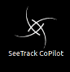

Figure 2 –SEETRACK COPilot Interface Icon

**Note**: Do right-button mouse click and then select Open to run the interface if it does not auto-start.

1. . The interface is now running (as shown below in FIGURE 3).

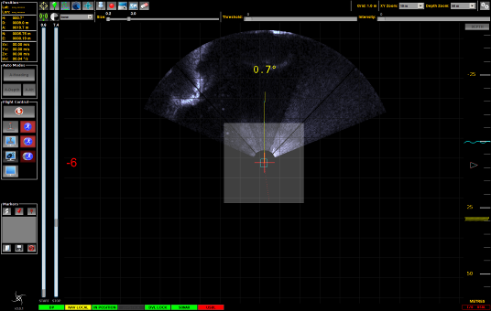

FIGURE 3 – SEETRACK COPILOT INTERFACE OVERVIEW

## Interfacing SeeTrack CoPilot

### Front Panel



Figure 4 – Interfacing the SeeTrack CoPilot unit Front Panel

The front panel indicates if the unit is running properly. USB connectors are also available for the user to plug in the mouse and other external devices.

**Note:** The front panel of the SeeTrack CoPilot hardware unit provides the user with critical information.

### Rear Panel



Figure 5 – Interfacing the SeeTrack CoPilot unit Rear Panel

The rear of the unit is where the power, remote emergency stop button, monitor and navigation sensors should be connected.

**Note:** The rear panel of the SeeTrack CoPilot hardware unit is where all the data communication occurs.

## Hardware Specification

### Front Panel Layout

The position and description of each connector are explained in Figure 6 and Table 1:



Figure 6 – SeeTrack CoPilot hardware unit Front Panel Layout

|  |  |  |
| --- | --- | --- |
| **PART** | **DESCRIPTION** | **TYPE** |
| J1 | On/Off button | Momentary push button |
| J2 | Power Indicator | LED |
| J3 | System Indicator | LED |
| J4 | USB 2.0 port | USB Type A |
| J5 | USB 2.0 port | USB Type A |
| J6 | Drive | DVD-RW/CD-RW |
| J7 | Hard Drive Disk 1 | N/A |
| J8 | Hard Drive Disk 2 | N/A |
| J9 | Reset button | Momentary push button |
| J10 | Fans and filter | N/A |

Table 1 – Front Panel Connections

### Rear Panel Layout

The position and description of each connector are explained in Figure *7* and Table 2:



Figure *7* – Rear Panel layout

|  |  |  |
| --- | --- | --- |
| **PART** | **DESCRIPTION** | **TYPE** |
| J1 | Mains Input 100-240 VAC 47-63Hz | IEC female |
| J2 | Mains Input 100-240 VAC 47-63Hz | IEC female |
| J3 | Mains indicator | LED |
| J4 | Power supply latch |  |
| J5 | Power supply latch |  |
| J6 | PSU indicator | LED |
| J7 | PSU indicator | LED |
| J8 | Mains ON/OFF | ON/OFF Rocker Switch |
| J9 | Mains ON/OFF | ON/OFF Rocker Switch |
|  |  |  |
| SLOT 1 | **E-Stop** |  |
| J1.1 | Remote Emergency stop | 2-pin round female |
|  |  |  |
| SLOT 2 | **Display** |  |
| J2.1 | VGA | 15-way D female |
| J2.2 | Not used |  |
| J2.3 | DVI | 29 pin female |
|  |  |  |
| SLOT 3 | **Serial Communications** |  |
| J3.1 | Serial ports (up to 4 ports using data cable  provided) | 25-way D male |
|  |  |  |
| SLOT 4 | **Spare** |  |
|  |  |  |
| SLOT 5 | **IB power** |  |
| J5.1 | Interface box power supply | 3-pin round female |
|  |  |  |
| SLOT 6 | **Fan** |  |
|  |  |  |
| SLOT 7 | **IO** |  |
| J7.1 | Not used |  |
| J7.2 | 10/100 Base-T Ethernet port (SeeByte use only) | RJ45 |
| J7.3 | 10/100 Base-T Ethernet port (SeeByte use only) | RJ45 |
| J7.4 | USB 2.0 port | USB Type A |
| J7.5 | USB 2.0 port | USB Type A |

Table 2 – Rear Panel Connections

### Power

The SeeTrack CoPilot unit accepts voltages from 100VAC to 240VAC (47-63Hz) from a universal mains AC power supply.

The mains inputs (J2 and J3) of the unit should be connected to an AC mains power supply using the power cables provided.

The unit is powered ON and OFF via two methods:

1. The power supply provides a standard ATX format; the power button on the front (J1) starts the power supply and shuts it down. This is the primary means of powering the unit ON and OFF.
2. On the rear of each power supply module there is a supply ON/OFF switch (J8 and J9). When the power button on the front of the unit (J1) is used, part of the power supply remains live; when the switches on the rear of the unit (J8 and J9) are used, the power supply is completely cut off.

### Emergency Stop Button

The SeeTrack CoPilot unit is equipped with **one** emergency stop button: it is a remote stop button and it is connected to a 2-pin connector (J1.1).

**Caution**: The remote emergency stop button should be plugged in at **ALL** times.

**Caution**: In the event of a DP failure, the pilot **must** cut out the DP system by pressing the remote emergency stop button. The pilot will then have total control of the ROV using their own joystick.

**Caution**: If the ROV stops responding, cut the DP system off immediately by pressing the emergency stop button.

### Communications

**USB ports**

Four USB ports are also provided for user-specific peripherals to be connected, a joystick, a keyboard, a mouse or storage devices. Two USB ports are located at the rear of the unit (J7.4/J7.5) and two are located at the front of the unit (J4/J5).

Each port is able to provide up to 500mA of current maximum. Each port is compliant with the USB 2.0 standard, and will support:

* **Hi-Speed** Mode (480Mbps)
* **Full-Speed** Mode (12Mbps)
* **Low-Speed** Mode (1.5Mbps)

**Ethernet RJ45 connectors**

Two Ethernet RJ45 connectors are located on the rear panel

**Caution**: The connectors should **NOT** be used except by SeeByte and when the ROV is controlled by an analogue or digital joystick. Please refer to section 10.1 – for further details.

**DB9 Serial RS32 ports**

Four ports are available to the user and are primarily used to plug in navigation sensors. These ports will read serial data from devices connected to the ports on the rear of the unit that use the RS232 hardware protocol. All ports are electrically protected.

The pin-out details for each DB9 connector are as follows:

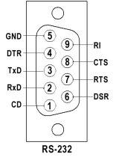

Figure 8 – Pin-out Details

|  |  |
| --- | --- |
| **PIN NUMBER** | **DESCRIPTION** |
| 1 | DC – Data Carrier |
| 2 | RxD – Receive Data |
| 3 | TxD – Transmit Data |
| 4 | DTR – Data Terminal Ready |
| 5 | GND – Ground |
| 6 | DSR – Data Set Ready |
| 7 | RTS – Request To Send |
| 8 | CTS – Clear To Send |
| 9 | RI – Ringing Indicator |

Table 3 – Pin-out Descriptions

### Display - Connection

**VGA/DVI video outputs:** these outputs (**J2.1 and J2.3**) allow the unit’s pilot interface to be displayed.

## Power Up/Down Procedures

### Switching the SeeTrack CoPilot Hardware Unit On

* Ensure that the **main power sockets** (**J1 and J2**) are plugged into AC mains.
* Press the **power** buttons (**J2 and J3**) on the power supply unit to **position 1.** The three indicators **J3**, **J6** and **J7** should be on.
* Now switch the unit on by pressing the **power On/Off** button (**J1**) situated at the front of the unit.
* The **power indicator** (**J2**) is now on.
* The unit is now on.

### Switching the SeeTrack CoPilot Hardware Unit Off

**Important Note**: Ensure that the emergency stop button is pressed before switching off the unit.

* **Shutdown Procedure**

From the taskbar:

1. Ensure that the emergency stop button is pressed.
2. Select the following icon  located on the top taskbar.
3. Select Shut Down...
4. Select Shutdown

* **Emergency Procedure**

1. Ensure that the emergency stop button is pressed.
2. Push and maintain the **On/Off** button (**J1**) for a few seconds until the system stops.
3. Press the **main power** buttons to position 0 (**J2** and **J3**) at the rear of the unit.



**Important Note**: The emergency procedure is **NOT** recommended and should only ever be used as a final option.

# Pilot Interface Overview

The SeeTrack CoPilot pilot interface presents the user with an overview of the ROV’s status and its position in the navigation chart. The overall look of the pilot interface is designed for use primarily in low light conditions and has also been designed to be easy to read and intuitive to use.

The SeeTrack CoPilot pilot interface comprises of four main elements:

* **Pilot Information Display**

The pilot information display is the column on the left side of the interface. It provides the pilot with vital information on the current status and operation of the ROV.

* **Navigation Chart Display**

The navigation chart display is the main panel in the pilot interface. It allows the user to monitor the position of the ROV in real-time. It is also possible to use the navigation chart display to generate commands for the ROV by selecting coordinates with a mouse. A left-button mouse click in this display generates a new position request for the ROV, and a right-button mouse click generates a new heading request.

* **Water Column Display**

The water column display is positioned on the right side of the interface, next to the navigation chart display. It allows the pilot to monitor and alter the depth/altitude of the ROV. A left-button mouse click in this display generates a new depth/altitude request for the ROV. A right-button mouse click has no effect in this display.

* **Pilot Interface Toolbar**

The pilot interface toolbar allows the user to access the additional functionalities of the interface.

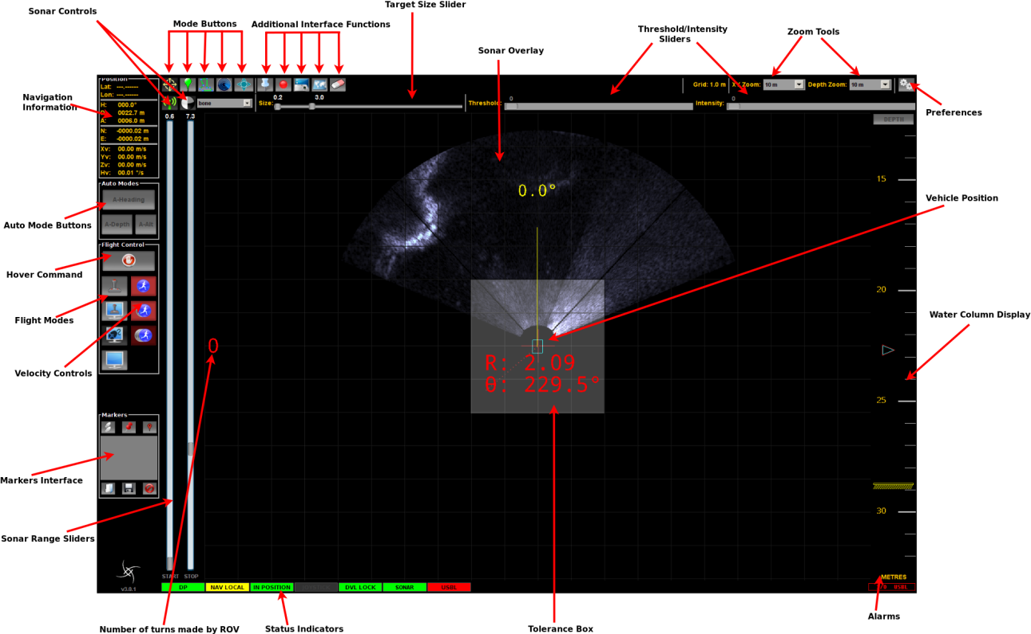

Figure 9 – Pilot Interface Overview

# Navigation Chart Display

The **navigation chart display** is centred on the ROV. It displays a plain view of the ROV and the surrounding area. The navigation chart is capable of displaying various objects – such as other ROVs, the TMS and the vessel – but can only control the main ROV in the centre of the view.

The ROV position is estimated by SeeTrack CoPilot’s navigation system – the accuracy of which depends on the frequency and quality of the absolute navigation fixes.

The view is always pointing to magnetic north; however the ROV will rotate in the centre of the screen to reflect the current ROV heading.

When in AUTOFLY mode, the main ROV is controlled in X (Surge), Y (Sway) and Yaw (Heading) in the navigation chart display using the mouse. A left-button mouse click changes the current target position to the new screen coordinates where the click occurred. The target waypoint is represented by a cross and a trajectory line is drawn between the current ROV position and the target waypoint. A right-button mouse click changes heading. The target heading is displayed by a line of fixed length from the current ROV position at the requested target heading. The target heading is also displayed as a number at the end of the target heading line.

The number of turns the ROV makes over its own axis is displayed on the left side of the navigation chart display. A clockwise turn is represented by a positive figure, and an anti-clockwise turn is represented by a negative figure.

The navigation chart also displays a grid as a form of reference. The grid square scale is specified by the grid size label. This scale changes with the zoom scale to improve its usability.

In addition to a grid, the navigation chart is also capable of displaying a user-defined water current direction and user-defined water current velocity. The navigation chart display is also responsible for displaying the head-up display messages indicating various system states.

## Navigation Chart Display Zoom Scale Control

The navigation chart display zoom scale allows the user to change the displayed size of objects in the viewable area. The scale of the viewable area is measured from the centre of view to the right or left edge of the viewable area. The scales are set to pre-defined values of 2m, 5m, 10m, 20m, 50m, 100m and 200m (or their equivalent values in feet).

# Water Column Display

The **water column display** allows the user to view the area above and below the ROV in the water column. The ROV remains in the centre of the display at all times. If the seabed is within range of the DVL or Altimeter, and is within the current field of view, it is also displayed.

The water column display can be operated in either depth or altitude mode. This option allows the ROV to remain at a constant user-defined value. In depth mode, the ROV will maintain the specified depth of the ROV relative to the sea surface; in altitude mode, the ROV will maintain the specified altitude of the ROV relative to the sea bed.

The depth/altitude mode can be changed by clicking on the button at the top of the water column display. For example, if the button indicates that the display is in ‘Depth’ mode, it will change to ‘Altitude’ when selected.

While in AUTOFLY or CRUISE mode, the user can control the ROV’s Z (Heave) axis by clicking above or below the centre of the water column display. The ROV will then ascend or descend to the specified depth or altitude, depending on the selected display mode.

The seabed icon is displayed in yellow and the sea surface in cyan. The **current** depth/altitude is represented by a cyan arrow and the **target** depth/altitude selected by the user is represented by an red arrow.

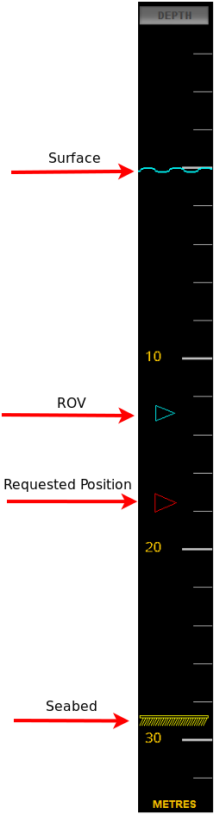

Figure 10 – ROV Moving in Water Column Display

## Water Column Display Zoom Scale Control

The water column zoom scale allows the user to change the displayed size of the area of interest around the ROV. Zooming out in this control allows the user to send requests further above or below the ROV. The ROV is always at the centre of the water column display; the seabed is also displayed but moves according to the current ROV altitude. The zoom scale of the viewable area is measured from the centre of view to the top or bottom of the viewable area. The scales are set to pre-defined values of 2m, 5m, 10m, 20m, 50m, 100m, 200m, 500m and 1000m (or their equivalent values in feet).

# Pilot Information Display

The **pilot information display** contains the essential navigation information required to operate the ROV with confidence and precision. This display provides the user with the current navigation data for the ROV and a visible indication of the selected flight control method.

The pilot information display comprises many user-friendly elements, including the current navigation information; status indicators; and flight mode and velocity selection.

## Navigation Information

This pilot interface feedback panel provides the user with the following ROV information: Latitude (**Lat**), Longitude (**Lon**), Heading (**H**), Depth (**D**), Altitude (**A**), North (**N**), East (**E**), Surge Velocity (**Xv**), Sway Velocity (**Yv**), Heave Velocity (**Zv**) and Yaw Velocity (**Hv**). This information is normally updated from the navigation system, but if the DP is in standby only the raw ROV information is displayed. No value is displayed if no ROV information is detected.

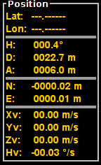

Figure 11 – navigation information

## Status Indicators

The status indicators on the pilot interface display allow the user to monitor the status of the system.



Figure 12 - Status Indicators

### The DP Status Indicator

This indicator displays the status of the DP system:

* The indicator is **green** when the DP system is running.



Figure 13 - DP running indicator

* The indicator is **red** when the DP system is in standby.



FIGURE 14 - DP STANDBY Indicator

The DP can go into standby if the ROV is not in working range (i.e. the DVL has no bottom-lock) or some critical error was detected. In this situation SeeTrack CoPilot changes into MANUAL mode and the pilot has full control.

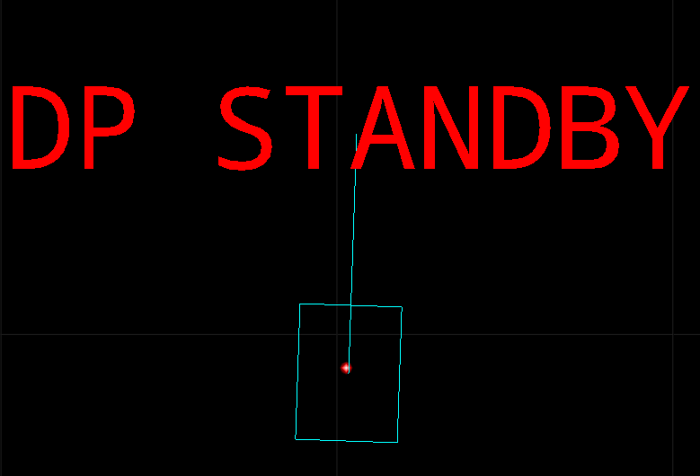

Figure 15 - DP STANDBY DISPLAY

### The Position Status Indicator

This indicator is illuminated **green** when the ROV is within the tolerance range of its target position. The indicator is not displayed when the ROV is not in position.



FIGURE 16 - IN POSITION INDICATOR

### The Joystick Indicator

This indicator is displayed **green** when the system receives a command from the joystick. The indicator is not displayed when the joystick is not considered to be in use.

If the joystick movement is within the specified deadband range, the system will not detect the command. For example, a joystick movement of 20% will not be detected by the system if the deadband setting is 30%.



Figure 17 - Joystick indicator

### The Navigation Status Indicator

This indicator can have four different displays, depending on the accuracy of the navigation system and the ROV’s global reference:

|  |  |
| --- | --- |
| **Indicator Appearance** | **Status** |
| Figure 18 – Nav Global Indicator | The navigation system is operating correctly (**green**), and the global position is accurate. |
| Figure 19 - NAV LOCAL INDICATOR | The global position may have a degree of imprecision – but it is still compatible with effective ROV operation (**yellow**). |
| Figure 20 – Nav Fault Indicator | The navigation system has failed (**red**). Only the MANUAL flight mode is accessible. |

Table 4 – navigation status indicators

### The DVL Lock Indicator

This indicator informs the user of the failure of the DVL sensor to get an adequate fix on the seabed. When this indicator is illuminated **red** the DP system will lose precision after a short amount of time. The ROV can be flown in MANUAL mode under these circumstances.



FIGURE 21 - DVL LOCK (loCK LOST) Indicator

When the DVL gets a fix on the seabed, the indicator is **green** displaying DVL and the system will return to normal operation.

### The External Position Fix Indicator



**Note**: An external interface might be required. The external position data could come from USBL, LBL, GPS or other available devices. The indicator will be labelled with the device category name (USBL, LBL or GPS).

This indicator informs the user if a position fix (Latitude and Longitude) is being received in a continuous manner to SeeTrack CoPilot. The indicator will turn **red** when no device is connected or if no data is being received. The indicator will turn **green** when data is received



FIGURE 22 – EXTERNAL POSITION FIX INDICATOR

### The Sonar Indicator

This indicator is displayed **green** when the sonar is connected to SeeTrack CoPilot. The indicator is displayed **red** when the sonar communications have failed or if the sonar is not connected.



FIGURE 23 – SONAR INDICATOR

## Markers

It allows the user to place markers onto the Pilot Interface to denote positions of interest to be returned to. These markers can be placed automatically at the vehicles current position, or manually at a position chosen by the operator. Marked areas can be saved and loaded by the operator for repeat missions.

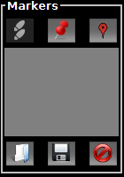

Figure 24 - Marker Panel Interface

### Placing a Marker at the Current Position



FIGURE 25 - MARK CURRENT LOCATION

The user can automatically drop a marker at the vehicles current position, which will be visually denoted by a gold dot on the Pilot Interface, by clicking the Place Marker Icon. The location of this marker will appear within the Markers interface.

### Manually Placing a Marker

The user can manually place a marker by selecting the Add Marker icon.



FIGURE 26 - ADD MARKER

The user will then be instructed to enter the coordinates of their chosen location into the window. Once entered, the user should click ‘OK’ to place the marker. If incorrect coordinates have been entered, a warning message will be displayed. Press Ok to add the marker to the display.

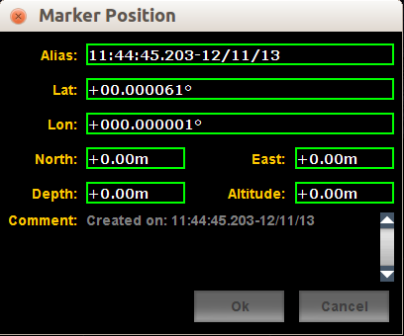

FIGURE 27 - ADDING A MARKER

**Note**: Hold the control (Ctrl) key and use left-button mouse click to quickly add a marker.

### Fly to Marker

Once a marker has been placed, the user can, at any time during their mission, instruct the vehicle to fly to the Marker by clicking on the chosen marker from the marker list and then selecting the Fly to Marker Icon.



FIGURE 28 - FLY TO MARKER



**Note**: Fly to Marker option is only available in Auto-Fly mode.

### Save Marker Positions

The user has the option of saving the position of their current marker(s) for use at a later date. To do this, the Save icon should be selected. Once clicked, the file will automatically be saved to the data directory. See section **Error! Reference source not found.** for more information regarding the data directory.



FIGURE 29 - SAVE MARKER LIST

### Load a Marker File

To load a previously saved Marker File, the user must select the Load icon.



Figure 30 - load marker list

By selecting the appropriate file from its location and selecting ‘open’, the saved markers will be loaded onto the current Pilot Interface and added to the marker’s list.

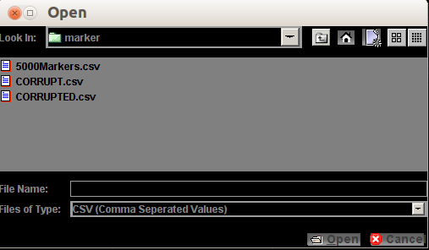

Figure 31 - Load Marker window

### Editing Markers

The user can edit the position and name (alias) of a specific marker:

* + Right-button mouse click on the marker to be edited within the Markers Interface list of markers
  + Select ‘Edit’ from the options provided
  + Edit the details as shown in section 7.3.2 and save. The marker position and name will now be changed.

### Deleting a Marker

To delete a marker, there are two possible actions that can be undertaken:

1. Using the Delete icon
   * Select the Marker you wish to delete from the Markers Interface list of Markers
   * Left-button mouse click on the Delete icon



Figure 32 - Delete Marker

1. Using the Markers Interface
   * Right-button mouse click on the marker you wish to delete from the Markers Interface list of Markers
   * Select Delete from the available options

Your chosen marker will now be deleted.

### Selecting Multiple Markers for Deletion

To select multiple markers from the Markers Interface list of Markers, the user should, whilst holding the control (Ctrl) key on their keyboard, select the markers they wish to delete by clicking on each marker.

All of the markers can also be selected by clicking on one of the markers in the list and then pressing Ctrl + A to select all of them.

## Flight Modes

Selecting the flight mode buttons on the pilot information display changes the flight mode and the active button is highlighted in dark grey with white text.

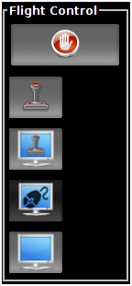

Figure 33 – Flight Mode Buttons

**Note**: When the DP is in standby, the only mode enabled is MANUAL and the rest of the buttons are disabled in the pilot interface.

### HOVER Command

The ROV maintains position when the ‘HOVER’ button is selected. The HOVER command can be used at any time to interrupt the vehicle’s motion and hold the position of the ROV.

The HOVER command provides station-keeping at the touch of a button and is useful for monitoring missions when the ROV must remain in a fixed position for long periods of time.

**Note**: The selected flight mode defaults to AUTOFLY whenever the ‘HOVER’ button is pressed – except when the AUTOHOVER flight mode is in use.

### Flying in MANUAL Mode

In MANUAL mode the pilot has full control as if the joystick is directly connected to the ROV, and the DP system is in standby. The pilot interface displays navigation data and monitors the position of the ROV.

**Note**: Selecting the ‘HOVER’ button will change the ROV into AUTOFLY mode.

**Example**

1. Select the ‘MANUAL’ button.
2. Fly the ROV manually with the joystick.
3. The ROV is moving on the navigation chart according to your requests via the joystick movements.

**Note**: Clicking in the navigation chart or water column display has no effect; the ROV responds to joystick commands only.

### Flying in AUTOHOVER Mode

In AUTOHOVER mode the pilot has full control as if the joystick were directly connected to the ROV. This mode provides station-keeping when no control inputs from the joystick are detected.

If the pilot releases the joystick, the DP system takes control and maintains the vehicle’s position. The pilot can use the joystick again to regain full control of the ROV.

**Example**

* Select the ‘AUTOHOVER’ button.
* Fly the ROV with the joystick.
* Release the joystick.
* The ROV holds position automatically.
* Fly the ROV around again via the joystick.

**Note**: Clicking in the navigation chart or water column display has no effect; the ROV responds to joystick commands only.

### Flying in AUTOFLY Mode

In AUTOFLY mode the DP system is in total control. The ROV can be controlled with both mouse and joystick commands, and when there are no commands the DP system provides station-keeping.

AUTOFLY mode also offers the user a range of additional **navigation tools** to assist in controlling the ROV. These navigation tools allow the user to plan detailed missions for the ROV with ease and precision.



Figure 34 – Navigation tool Buttons

#### Click & Go Navigation Tool

Click & Go is the default navigation tool in AUTOFLY mode. The pilot can select a set of coordinates by clicking on the screen using the mouse and the ROV will then fly to those coordinates and go into a stable hover. Alternatively, the ROV can be moved using a joystick input and will **decelerate** to a stable hover when the joystick is released. This method of station-keeping provides a smoother halting manoeuvre for the ROV, and is only available in the AUTOFLY flight mode.

**Example**

1. Select the ‘AUTOFLY’ button.
2. Choose a speed (SLOW, MEDIUM or FAST); the ROV will aim to move at the chosen speed.
3. The depth/altitude of the ROV can be altered at any time using the water column display.
   * **Mouse Commands**
     1. A right-button mouse click on the navigation chart display will change the heading of the ROV (a new line at the chosen heading will appear).
     2. A left-button mouse click on the navigation chart will select a target destination.
     3. The requested waypoint will appear on the screen represented by a cross.
     4. The ROV will move towards the chosen position.
     5. Once the target has been reached the ‘IN POSITION’ indicator will illuminate and the ROV will maintain position until a new destination is chosen.

* **Joystick Commands**

1. A command from the joystick controls the ROV at a velocity proportional to the chosen speed (SLOW, MEDIUM or FAST).
2. The green arrow indicates the direction of the pilot’s velocity request.
3. When the joystick is released the ROV will decelerate as quickly as possible until it reaches a resting point, and will then maintain position until the system receives another command.

**Note**: If the ROV takes too long to decelerate to a resting point, the DP system will activate a HOVER command.

#### Specific Waypoint Navigation Tool

The **Specific Waypoint** navigation tool allows the user to manually send the ROV to a specific position using absolute or relative coordinates.

There are three methods of identifying the specific waypoint:

1. **Global**

This option allows the user to specify the waypoint by entering the latitude, longitude, depth/altitude and heading coordinates. The user can choose whether to enter depth or altitude coordinates by selecting the appropriate format in the drop-down box. The user also has a choice of formats for entering latitude and longitude: decimal degrees; degrees and decimal minutes; and degrees, minutes and seconds.

**Note**: Latitude and longitude coordinates are always on WGS84 reference datum.

1. **Local**

This option allows the user to specify the waypoint by entering the north, east, depth/altitude and heading coordinates. The user can choose whether to enter depth or altitude coordinates by selecting the appropriate format in the drop-down box.

1. **Relative**

This option allows the user to specify the waypoint by entering coordinates relative to the ROV’s current position. The waypoint request can be specified using any or all of the following four fields:

* **Forward/Backward** (m): A positive figure in this field will make the ROV move forward. A negative figure in this field will make the ROV move backward.
* **Lateral Left/Right** (m): A positive figure in this field will make the ROV move right. A negative figure in this field will make the ROV move left.
* **Up/Down** (m): A positive figure in this field will make the ROV go down. A negative figure in this field will make the ROV go up.
* **Turn Left/Right** (degrees): A positive figure in this field will make the ROV turn right. A negative figure in this field will make the ROV turn left.

**Note**: Forward is positive, Lateral right is positive, Down is positive and Turn right is clockwise.

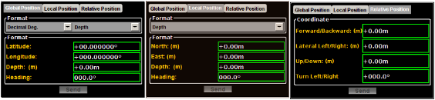

Figure 35 – Waypoint Options

The user must first select the required method of specifying the waypoint by selecting the appropriate tab at the top of the Waypoint panel.

The user must then enter the precise figures for each field according to the chosen method of determining the waypoint.

By selecting the ‘Send’ button, the command is activated and the ROV is directed to the specified coordinates.

**Note**: If the user attempts to send the ROV to an invalid coordinate, a dialogue box will appear to advise that the waypoint request is impossible to achieve.

#### Survey Plan Navigation Tool

The **Survey Plan** navigation tool is used to prepare a mission for the ROV by either planning a path on -screen or uploading a saved path.

The user can specify the coordinates, depth/altitude, heading and wait time for each of the waypoints in the path before the ROV begins its mission. When activated, the ROV will automatically follow the designated path with no further input from the pilot, unless interruption is deemed necessary.

The Survey Plan navigation tool allows the pilot to observe and monitor the ROV instead of negotiating its path manually.

The user can employ two methods to plan a path for the ROV:

* **Planning a Path Using the Mouse**

The user should indicate the position and heading for each of the waypoints using the mouse.

* The **position** must be determined first, with a left-button mouse click; and
* the **heading** determined second, using a right-button mouse click.

The waypoints are assigned an ID number as they are registered on the navigation chart, to remind the user of the order of sequence.

**Note**: Holding control key (Ctrl) and pressing Z key will delete the last waypoint entered.

**Note**: It is possible to only use left-button mouse clicks to plan a mission. In that case the heading will be automatically calculated based on the direction of the line.

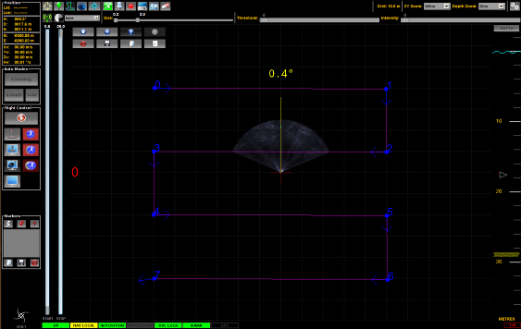

Figure 36 – Survey Plan Path

* **Planning a Path Using the Editor**

It is also possible to plan a path by selecting the ‘Edit’ button and entering the required data manually for the series of waypoints.

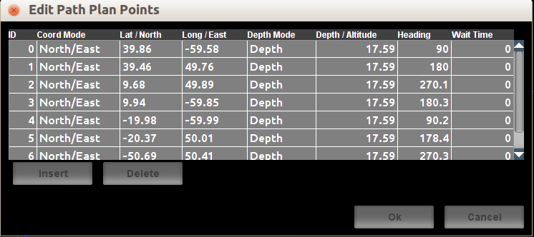

Figure 37 – Survey Plan Editor

To begin planning a path using the editor, the user must select the ‘Insert’ button. This will produce a line of data detailing the ROV’s **current** position, which the user can then amend to specify the first waypoint for the ROV’s path.

Additional waypoints can then be added by repeating this process.

The user can enter the coordinates for the waypoint in two formats:

1. **latitude/longitude** (in decimal degrees); or
2. **north/east**.

**Note**: Latitude and longitude coordinates are always on WGS84 reference datum.

The user also has the option of selecting either depth or altitude mode when specifying the waypoint.

The path will be loaded and displayed on the navigation chart by selecting the ‘OK’ button.

**Editing a Path**

Whether it was created using the mouse or editor, the user can edit the details of a path by selecting the  (Edit) button to display the Edit window.

The coordinates, depth/altitude, heading and wait time (in seconds) for a waypoint can all be altered by selecting the appropriate field and entering the required data.

It is possible to insert new waypoints within the path by selecting the entry in the table directly after the desired position of the new waypoint, then pressing the ‘Insert’ button. For example, if the user wishes to insert a new waypoint between positions 2 and 3, they should select the entry in the path table with the ID number 3, then select ‘Insert’. This will produce a new entry with coordinates exactly half-way between the waypoints 2 and 3. This data can then be amended according to the particular values of the new waypoint.

It is also possible to delete waypoints by first selecting the appropriate entry in the editor table, and then pressing the ‘Delete’ button.

**Note**: Holding control key (Ctrl) and pressing Z key will delete the last waypoint entered.

**Running a Path**

To run the mapped path, the user must select the  (play) button. The ROV will then fly each line, before moving on to the next. The  (pause) button can be used to suspend the journey, and the  (stop) button can be used to stop the journey completely. The path can be removed at any time by selecting the  Clear button.

The  (skip forward) button when pressed skips the current waypoint.

The  (reverse) button when pressed will start reversing the path to the beginning of the path.

When the ROV has completed the Survey Plan sequence, the user can select the  (play) button again to repeat the journey or  (reverse) to reverse the entire path.

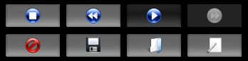

Figure 38 – Survey Plan Buttons

**Saving a Path**

A path can be saved at any point by selecting the  (Save) button and entering an appropriate file name and location.

**Loading a Path**

Saved paths can be loaded by selecting the  (Load) button and opening the appropriate file.

**Deleting a Path**

Selecting the  (Clear) button will remove the path and the path data will not be saved.

**Note**: Although a path may remain visible if the user selects another cursor tool, the ROV will only follow the path when the Survey Plan tool is selected.

#### Tracking Navigation Tool

When the Target Tracking mission mode button is pressed the target tracking dialog is opened on screen which allows the user to perform tracking commands on potential targets.

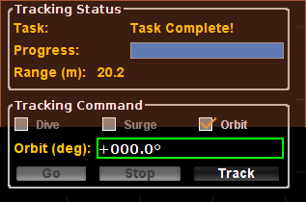

Figure 39 – tracking display

The colour of the target box indicates the status of the tracking system:

* **A Solid green** indicates a currently tracked target selected by the user.
* **A Dashed yellow** box indicate a detected target

The user must press the TRACK button to enable the tracking. The user can press a left-button mouse click to select a highlighted target (Dashed yellow box). If the tracking module successfully locks on, the box turns green. The ROV will adjust automatically its heading to face the target.

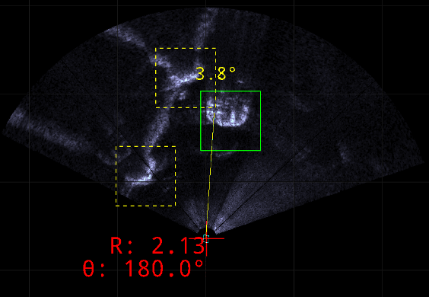

Figure 40 – tracking A TARGET

A right-button mouse click performs the same behaviour as a left-button mouse click – but in this instance a point is tracked.

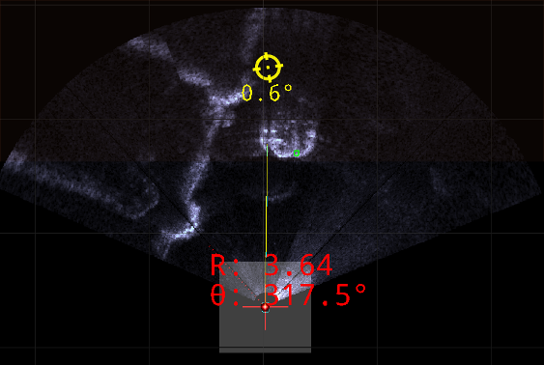

Figure 41 – tracking A POINT

When the TRACK button is pressed the tracking status and command controls are displayed.

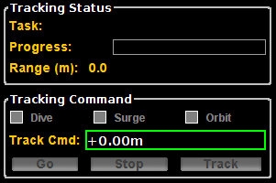

Figure 42 – tracking PANEL

There are two ways to control the vehicle once the target is acquired.

1. **Tracking Panel Commands**

The user can select three different tasks such as dive, orbit and surge. All the motions are relative to the target.

The Orbit task commands the vehicle to orbit around the target either in a clockwise or counter clockwise direction. For example if 180 degrees is selected, the vehicle will move around the target by 180 degrees (clockwise) from its present position.

The Dive task commands the vehicle to either dive (when a positive request is entered) or rise (when a negative request is entered).

The Surge task commands the vehicle to either move forwards (when a positive request is entered) or move backwards (when a negative request is entered). No requests within a radius of 2 m of the target are allowed.

By pressing the GO button the selected task will start. The task progress is constantly updated along with the range to the target. Once the task is accomplished the vehicle will hover.

The user is able to stop the tracking command at any time by pressing the STOP button.



**Note**: Clicking the ‘HOVER’ button will result in the target lock being released and the system will default to normal AUTOFLY operation.

1. **Joystick Commands**

The joystick commands the vehicle to move relative to the target. For mid-water objects, such as a riser, the vehicle will orbit the target in a clockwise or counter clockwise direction when the joystick is pushed laterally. Pushing forward or backwards on the joystick increases or decreases the range to the target. The vertical control commands the vehicle to dive or rise.



**Note**: Clicking the ‘HOVER’ button will result in the target lock being released and the system will default to normal AUTOFLY operation.

#### Online Follow

SeeTrack CoPilot can receive waypoint data from an external interface. As soon as a new waypoint is received the vehicle will move automatically to it. This tool can only be used when SeeTrack CoPilot is in Auto-Fly mode. The user should click on the toggle button in order to activate this tool. Clicking on any other navigation tool or the Hover button will result in the SeeTrack CoPilot system disabling the Online Follow tool. Therefore the system will ignore incoming waypoint data.



**Note**: This mode is only available if the required interface is present. This feature can be used if the ROV needs following the main vessel.

### Flying in CRUISE Mode

CRUISE mode is ideal for survey work when the ROV must keep a constant heading and speed irrespective of the currents.

In CRUISE mode the DP system is in total control and the ROV moves in a straight line at a constant depth/altitude, heading and forward velocity. The joystick or mouse can be used at any time to alter the heading, depth/altitude and velocity of the ROV – without interrupting the CRUISE mode. The pilot may also adjust the position of the ROV to an alternative trajectory parallel to the vehicle’s current heading using the joystick or a left-button mouse click.

**Note**: If the user selects any of the cursor tools except Click & Go while in CRUISE flight mode, the system will automatically default to AUTOFLY mode.

**Example**

1. Select ‘CRUISE’**.**
2. The ROV is now moving forward at the chosen speed (SLOW, MEDIUMorFAST) and is keeping its depth/altitude and heading.
3. The depth/altitude of the ROV can be changed at any time using the water column display.
   * **Mouse Commands**
     1. A right-button mouse click on the navigation chart display will change the heading of the ROV (a new line at the chosen heading will appear).
     2. A left-button mouse click on the navigation chart will select a new position for the ROV. (Whilst in this mode, however, a command to adjust the position of the vehicle will only allow the user to direct the ROV to a point that is parallel to the ROV’s current heading.)
     3. The requested position will appear on the screen represented by a cross and it will move parallel to the ROV.
     4. The ROV will then be aligned with the chosen position, whilst maintaining a constant depth/altitude, heading and forward velocity.
     5. The ROV will continue cruising until the user exits ‘CRUISE’ mode or interrupts the flight using the ‘HOVER’ button.
        + **Joystick Commands**
          1. The joystick can be used to adjust the position of the ROV. (Whilst in this mode, however, a command to adjust the position of the vehicle will only allow the user to direct the ROV to a point that is parallel to the ROV’s current heading.)
          2. The requested position will appear on the screen represented by a cross and it will move parallel to the ROV.
          3. The ROV will be aligned with the chosen position, whilst maintaining a constant depth/altitude, heading and forward velocity.
          4. The ROV will continue cruising until the user exits ‘CRUISE’ mode or interrupts the flight using the ‘HOVER’ button.

## Velocity Controls

As with the flight mode buttons, the **Velocity Control** buttons serve to change the ROV velocity and indicate the current setting by highlighting the selected button in dark red.



Figure 43 – Velocity Control Buttons DEFINED AS FAST- MEDIUM AND SLOW

This velocity control is only available in AUTOFLY and CRUISE modes.

**Note**: Velocities are defined during the commissioning of the system and are dependent on the capability of the ROV. Usually MEDIUM is half of FAST and SLOW is one eighth. All axes are affected by the change in velocity.

## Single Axis Auto Modes

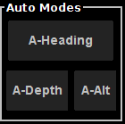

Figure 44 – SINGLE AXIS Auto Modes



**Note:** All single axis auto modes are only available when DP is enabled.

It is possible to engage multiple auto-modes at the same time such as auto-heading and auto-depth or auto-altitude.

### Auto-Heading

This is a single axis control. The ROV will maintain current heading or change heading if a right-click mouse command is issued. The ROV will turn to the new specified heading.

### Auto-Depth

This is a single axis control. The ROV will maintain current depth or change depth if a left-click mouse command is issued (clicking in the water column). The ROV will fly to the new specified depth.

### Auto-Altitude

This is a single axis control. The ROV will maintain current altitude or change altitude if a left-click mouse command is issued (clicking in the water column). The ROV will fly to the new specified depth.

## Sonar



**Note:** A sonar device needs to be connected to SeeTrack CoPilot computer.



**Note:** Sonar controls and features are device dependent and might not be available to all sonar devices.

### Reset Sonar Communications



Figure 45 - Reset sonar comms

If the user wishes to close any existing connections to the sonar and open a new connection, they can do so by simply clicking on the **Reset Sonar Comms** icon. This function should be utilized in instances when communication with the sonar has been interrupted.

### Auto-Intensity On/Off



**Note:** Sonar dependent,might not be available or replace with different controls.



Figure 46 - Enable / Disable Auto-Intensity

By default, CoPilot automatically adjusts the image intensity to produce an optimum image for most situations. However, there are some cases where you may wish to disable this feature. You can do so by un-checking Auto Intensity under the Pilot Interface Toolbar. With auto-intensity disabled, CoPilot shows the horizontal Threshold and Intensity sliders in the toolbar.

### Intensity/Threshold



**Note:** Sonar dependent,might not be available or replace with different controls.



Figure 47 - Intensity and threshold sliders

Lowering the threshold will allow more of the background to be displayed in the image. Increasing the threshold will suppress background noise, increasing the contrast of the image. The intensity control affects the brightness of the image. This is similar to brightness controls on a camera. Setting the intensity too low or too high will make the image dim or blown out respectively, making image details difficult to see.

### Colour map

The colors used in displaying the sonar image are referred to as the colour map. The selected colour map for the image is displayed in a drop down box on the CoPilot Interface toolbar. It is recommended to experiment with the different colour maps to best understand their individual strengths and weaknesses.

### Target Size Slider



Figure 48 - Target Size Slider

The target size slider allows the user to specify which size range of potential targets should be tracked whilst using the tracking navigation tool. The first slider is the minimum size and the second slider is the maximum size of the target. Refer to section 7.4.4.4 for more information regarding the tracking navigation tool.

### Sonar View Range Sliders



**Note:** Sonar dependent,controls might be limited.



Figure 49 - Sonar Range Sliders

The sonar range sliders (along the immediate left side of the interface) allow you to change both the start and stop range. The Stop Range selects how far out the sonar is looking, whereas the Start Range selects the point where the sonar starts acquiring data. By using both controls you can zoom in on a target. However, note that zooming in too far can create a degraded picture because not enough data is available to fill the screen pixels, resulting in pixilation.

## Alarm Panel

The **alarm** **panel** is displayed across the bottom of the pilot interface. It displays the current status of each software component that allows SeeTrack CoPilot to run smoothly.

If a software component fails, its name is illuminated in the alarm panel situated along the bottom of the pilot interface.

In normal operation, the bar illustrated below should have no alarms illuminated, and it will remain invisible to the user until any failure occurs.



Figure 50 – Alarm Panel

**Note**: Please refer to the *Troubleshooting and FAQ* guide for more details on the pilot interface alarms and the appropriate response to each.

**Caution**: If any alarm is activated, the DP system must be immediately cut off by pressing the emergency stop button.

## Additional Functions

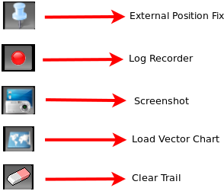

Figure 51 - Additional interface functions

### External Position Fix

By selecting the External Position Fix button, the user is presented with the Update Global Reference window which gives them two options:

1. **Reset Navigation Origin**

It allows the user to reset the navigation origin, by selecting this and pressing the OK button the vehicles north and east values are reset to 0.



**Note:** This can be used when the user needs to run the same survey path (pattern) multiple times. A survey path can be designed in North and East positions, saved and loaded. The user would first fly the ROV to position, reset the Navigation origin and finally load the path.

(See section 7.4.4.3 for more information regarding the survey plan navigation mode).

1. **Manually enter updated global position**

It allows the user to manually enter the global position of the ROV to update the navigation system.



**Note:** If an external position fix device is fitted to the computer the global position can automatically be updated to SeeTrack CoPilot without having to manually update it.

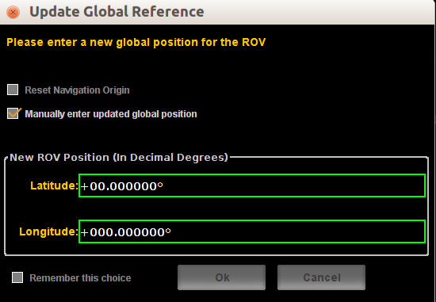

Figure 52 - Update Global Reference DIALOG

By checking the ‘remember this choice’ box before exiting the dialogue box, the system will store the details of the request and remember them the next time SeeTrack CoPilot starts-up

### Log Recording

The Log Recording icon allows the user to record sonar sequences and mission data which are automatically saved to the data directory. Refer to section **Error! Reference source not found.** for more information.

Once selected, the icon will blink to indicate recording in process. When the button is pressed for a second time this will stop the recording and the button will stop blinking to indicate the logs are not being recorded. Taking a Screenshot

A screenshot of the current interface display can be taken by selecting the Screenshot icon. By selecting this icon, a screenshot of the current interface display will be captured and saved to the data directory.

### Load Vector Chart

The Load Vector Chart menu item allows the user to add a vector chart to the navigation chart display. It can only display one chart at a time. The vector chart must be an AutoCAD® 14 DXF file in UTM WGS84 format and the chart must not exceed the boundaries of the relevant UTM zone.

**Important Note**: The Navigation Status indicator on the pilot information display must be green in order for the chart to be loaded. Please refer to section **7.2.4 –** The Navigation Status Indicator for more information.

**Note**: The user must know which UTM zone the chart was created in.

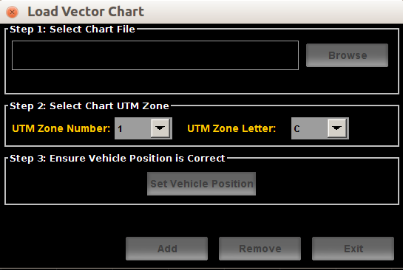

Figure 53 – Load Vector Chart

The Load Vector Chart dialogue box comprises three steps:

* **Step 1**:

Selecting the ‘Browse’ button opens up a dialogue box, through which DXF chart files may be selected.

When the appropriate file is located and the ‘Open’ button is selected, the chart is ready to be loaded, and the appropriate file name should appear in the file name display.

* **Step 2**:

When a valid file has been selected the file name will be displayed. The user must then select the correct UTM zone to position the chart using the drop-down lists.



**Important Note**: If an incorrect zone is chosen the chart will not be positioned correctly but may still appear in the view.

* **Step 3:**

The user must ensure that the vehicle position is correct before loading the vector chart. If the Navigation Status indicator is green (GLOBAL Position), this step is optional. If the Navigation Status sensor is yellow (GLOBAL Position not seeded to SeeTrack CoPilot), this step should be performed by selecting the ‘Set Vehicle Position’ button. Refer to section 7.2.4 for more information about indicators.

Select the ‘Add’ button to insert the chart on to the navigation chart display. Select the ‘Exit’ button to close the dialogue box.

**Removing a Chart**

Selecting the ‘Remove’ button removes the current chart displayed in the navigation chart display. If no chart is present, no action is taken.

### Clearing Breadcrumb Trail

As the ROV moves across the Pilot Interface, a breadcrumb trail will be left, highlighting the path of the vehicle. This path can be cleared by simply selecting the Clearing Breadcrumb Trail icon.

**Note:** To disable the breadcrumb trail, refer to section 7.10.2.2

## Preferences

### Units

The user can change the display measurement (position) units used in the interface to **meters** or **feet**. The velocity units can also be changed to **m/s**, **ft/s** or **knots**.

The global position can also be changed to decimal degrees (DD.dddddd), degrees and decimal minutes (NDD MM.mmm), or degrees, minutes and seconds (NDD MM' SS.sss”).

### Additional Features

The features tab in the preferences menu provides the user with some added features which can be enabled or disabled by clicking the check box.

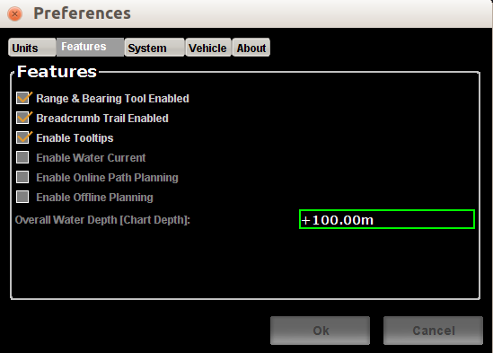

Figure 54 - Additional features

#### Range and bearing tool

It displays the range and bearing information from the ROV to the cursor.

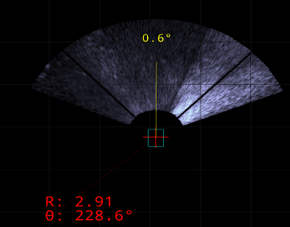

Figure 55 - Range and bearing tool

#### Breadcrumb Trail Enabled

A history of the ROV’s positions is displayed on the navigation chart.

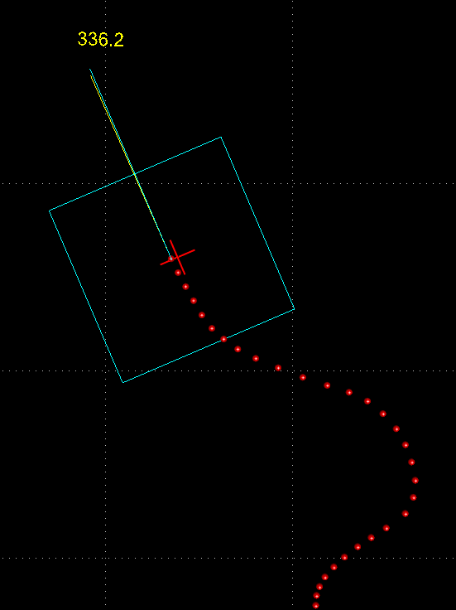

Figure 56 – Vehicle Trail

#### Enable Tooltips

Tooltips are available on most of the buttons and features on the pilot interface. The tooltips are used to inform the user of the function and purpose of a certain feature or button.

#### Enable Water Current

The Water Current feature offers the user the option of entering the heading and speed of the current, and then displaying this information on the navigation chart.

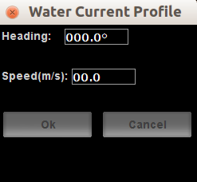

Figure 57 – Water Current Profile

In order to apply the specified values for the heading and speed of the water current, the user must check the box marked ‘Enabled’ and then select ‘OK’. The information will then be displayed on the right edge of the navigation chart.



Figure 58 – Water Current Display

#### Enable Online Path Planning

**Note:** An external interface is required to enable this feature.

When SeeTrack CoPilot receives a sequence of waypoints it will then automatically load the mission path in the navigation chart display.

The mission file will always be saved in a specific folder for the user to use at a later time if required. The format of the file is a .csv file and it is dated and time stamped.

#### Enable Offline planning

This mode allows the user to plan a survey mission, load a chart, fly the ROV without the need of having the ROV deployed in water. The user is also able to add markers and make the ROV fly to the desired marker.

#### Set Overall Water Depth

When in offline mode the user can specify the overall water depth by entering a value in the text field and pressing the OK button.

### System

#### Vehicle Chooser

The Vehicle Chooser allows the user to select the preferred control settings. These settings are stored for different vehicle types or payloads. The user should select the appropriate settings from the list available and then press the ‘OK’ button to confirm the choice.

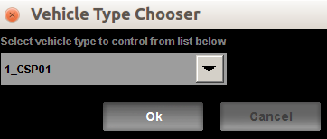

Figure 59 - Vehicle chooser

#### Joystick Calibration

This menu item is used to calibrate the joystick that is currently connected to the SeeTrack CoPilot system.

**Caution**: The joystick calibration should be completed before the ROV is ready to be operated – i.e. before it is in the water.

After selecting this menu item, the user has the option to begin the sequence of interactive processes required to complete the calibration of the joystick. The user is led through this series of steps by a wizard.



**Important Note**: Once the calibration process has started it cannot be stopped and must be completed.

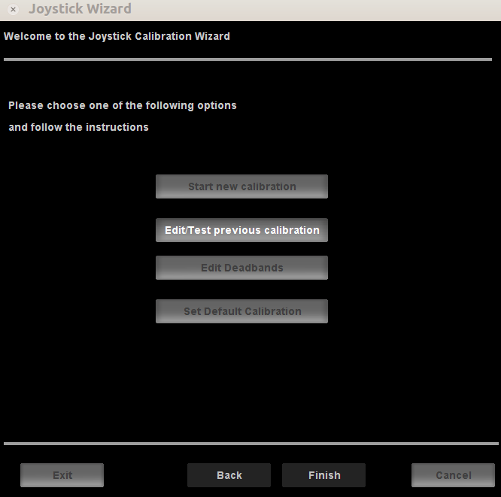

Figure 60 – Joystick Calibration

The Joystick Calibration menu item also offers three other options regarding joystick settings:

1. The ‘Set Default Calibration’ button will restore the joystick settings that were pre-defined during the SeeTrack CoPilot installation process.
2. The 'Edit/Test previous calibration' button opens previous settings which can be edited and then the changes can be saved.
3. The ‘Edit Deadbands’ button generates a dialogue box that will allow the user to adjust the deadband settings of the joystick.

**Caution**: Do not attempt to access or operate the ‘Deadband’ feature unless advised otherwise by SeeByte.

**Note**: Selecting the ‘Exit’ button in the ‘Deadband’ feature will close the dialogue box, but will not save the settings.

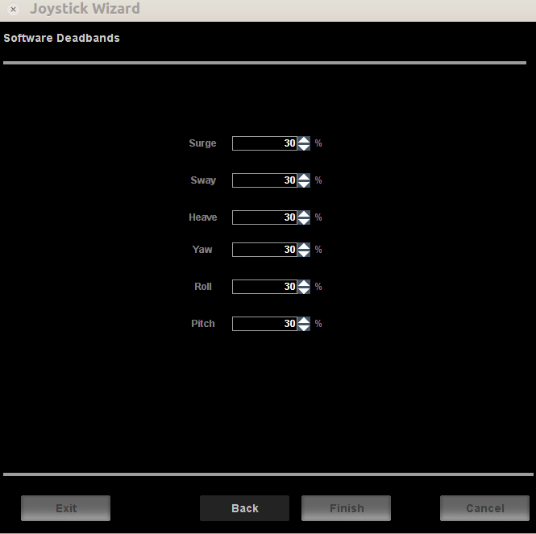

Figure 61 – Deadband Settings

#### Sensor Driver

The Sensor Driver menu item is used to manage and set up the serial data for the drivers that are either present or active in the system.

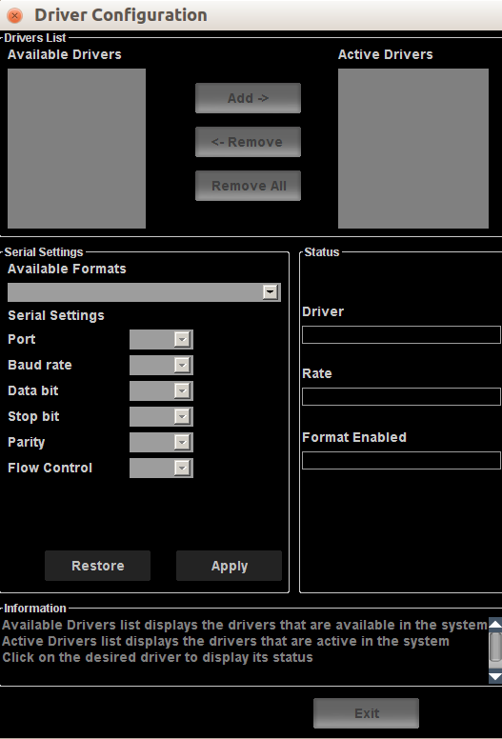

Figure 62 – Drivers Configuration

The **Driver List** box is used to manage the available and active drivers within the system. The drivers that are present in the system can be added to the ‘Active’ list by selecting the driver name and then pressing the ‘Add’ button. They can be deactivated and returned to the ‘Available’ drivers list by selecting the driver name and then pressing the ‘Remove’ button. All of the drivers can be removed from the ‘Active’ list by selecting the ‘Remove All’ button.

The **Serial Settings** box is used to set up the serial data for each of the active drivers. To change the settings of a particular driver, the user must click on the appropriate title in the **Drivers List** box, which will populate the settings for that driver into the **Status** and **Serial Settings** boxes.

The serial settings can only be applied once the driver appears in the ‘Active Drivers’ list in the **Driver List** box.

If a driver is already enabled – meaning that its status is either ‘ON’, ‘WRONG FORMAT’ or ‘NOT CONNECTED’ – it will automatically appear in the ‘Active’ list. Therefore this driver will appear in both lists. At that point serial settings and/or driver formats can be changed.

* **WRONG FORMAT**: This means that the selected driver format is wrong and should be changed. This can be debugged by using the serial tool as explained in the *Troubleshooting and FAQ* guide.
* **NOT CONNECTED**: This means that the driver is not receiving data. Either the sensor is not sending data to SeeTrack CoPilot or the cable is not plugged into the SeeTrack CoPilot hardware unit. This can be debugged by using the serial tool as explained in the *Troubleshooting and FAQ* guide.
* **ON**: This means that the driver is correctly receiving data.

**Note**: If the driver status is displayed as ‘ON’ but the rate is displayed as 0 msg/sec, the serial data for that driver are not properly set.

If the status of the driver is set to ‘OFF’ it will remain in the Available Drivers list. At this point the driver can be added. Once it appears in the Active Drivers list, its serial settings can be retrieved by clicking on the driver name.

Once the driver has been selected from the ‘Active Drivers’ list, the user can enter the serial data for the driver into the corresponding fields in the **Serial Settings** box. In order to apply these settings the user must select the ‘Apply’ button. The pre-defined default settings for the driver can be resumed at any point by selecting the ‘Restore’ button.

**Note**: It is important to remember to click the ‘Apply’ button after entering the serial settings for the selected driver. If the user does not do this before selecting another driver or exiting the dialogue box, the driver settings will not be applied.

The **Status** box allows the user to monitor the current status, rate and enabled format of the selected driver.

### Vehicle

The vehicle tab in the preferences menu allows the user to set the position of the sensors that are being used on the vehicle.

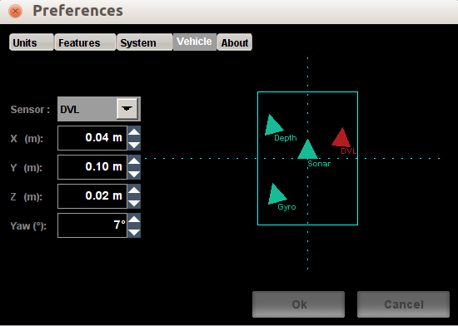

Figure 63 - Vehicle setup



**Note**: Sensor positions are measured from the origin being the top centre of the buoyancy of the vehicle as shown by the dotted lines.

* Positive X is aft
* Positive Y is starboard
* Positive Z is down
* Positive Yaw is clockwise

**Note**: It is important to accurately measure sensors’ position on the vehicle in order to improve the DP performance.

### About

The about tab provides information regarding SeeTrack CoPilot.

## Data Directory

All data is saved to a data directory. A shortcut (Link To Data) on the Desktop is available to navigate to the data folder

Within the directory subfolders are divided as follow:

* **Chart**
  + This folder is where all Charts should be stored as it is the default location that CoPilot checks for charts when the load chart button is pressed.
* **Marker**
  + This is where the user should store all marker lists and is where marker lists will be saved when the save marker list button is pressed.
* **Mission**
  + Where previous missions that have been saved can be found, is also the default folder for when a mission is saved.
* **Navigation**
  + This is where the navigation logs can be found when the log recorder has been activated.
* **Screenshot**
  + This is where screenshots can be found when the screenshot button is pressed.
* **Sonar**
  + Sonar logs can be found here when the log recorder has been activated.

# Flying with Dynamic Positioning

Dynamic positioning allows an ROV to automatically hold a requested position.

SeeTrack CoPilot controls Surge (X), Sway (Y), Heave (Z) and Yaw (Heading). The origin of each axis, such as where the depth is measured from, is usually set to the centre of the ROV for surge and sway, the forward centreline of the ROV for yaw, the top of the ROV for depth and the bottom for altitude (both are components of heave).



Figure 64 – Control Axis

When the DP system tries to HOVER in a fixed position, the set points are set to the ROV’s actual position at that moment. If moving at speed the ROV’s inertia will carry it past the waypoint; however the DP system will attempt to counter this by using maximum reverse thrust. The DP system will stop the ROV a little way past the waypoint then gently reverse back to the waypoint, as shown below in .



Figure 65 – Flying with DP

A DP system automatically does what a pilot would do in adjusting the thrusters to keep the desired position. However, just as a pilot can only keep a position to within a certain tolerance, the DP system also has a tolerance.

Inside that tolerance, or footprint, the ROV position is unpredictable but will generally only change slowly. It is very difficult to move the ROV’s actual position for distances less than the footprint.



FIGURE 66 – TOLERANCE OVERVIEW

If the tolerance is, say, 0.3m, the ROV will be within 0.3m of the requested position. If, however, the pilot wants the ROV to move 0.1m to the left, the waypoint can be moved 0.1m to the left – but there is no guarantee that the ROV’s actual position will move 0.1m to the left because it is still within the footprint of the new position.

This effect can also be seen in both heading and depth as shown below in Figure 64.



Figure 67 – Depth Tolerance Overview

# Appendix A

## Technical Specifications

|  |  |
| --- | --- |
| **ENVIRONMENTAL** | |
|
| Operating Temperature | 0° C to 40° C |
| Weight | < 10 kg |
| Size | Standard 19" 2U rack mount |
| **POWER** | |
|
| Supply Voltage | 100 VAC to 240 VAC |
| Surge Power | 170 W |
| **SYSTEM REQUIREMENTS** | |
| Doppler Velocity Log | Teledyne RDI Workhorse Navigator (preferred model) |
| Data Format Supported | PD0/PD6/PD13 (Teledyne RDI formats) Supplied with updates > 5Hz |
| Depth and Heading | Supplied with updates > 5Hz |
| ROV Thrusters Control | Analogue joystick or digital command system with updates > 5 Hz |
| Sonar | The Tracking module requires an input from a sonar |
| **USER INPUTS AND OUTPUTS** | |
|
| Connectors | 4 Serial RS232, 4 USB, 2 Ethernet (SeeByte use only) |
| Indicators | Status LEDs (Power, System) |
| **INSTALLATION** | |
|
| Compatibility | Simple retrofit, no modification needed to ROV |
| Integration | 1 day (12 hours) of ROV dry commissioning  1 day (12 hours) of ROV in-water commissioning; 2 hours for SAT  Additional time for training if required  Water space: minimum of 20m long x 20m across x 10m depth |

Table 5 – Technical Specification

# Appendix B

## Interface Box

The interface box itself is ROV-specific but allows the interfacing of generic controls such as surge, sway, heave and heading to the SeeTrack CoPilot hardware unit. The interface box connection provides power and switching control lines to allow control to be switched between SeeTrack CoPilot and the default joystick manual control.



Figure 68 – Connecting the ROV Interface Box to the unit

## Interface Box Front Panel Layout

The position and description of each connector are detailed in and :



Figure 69 – Interface Box Front Panel Connectors

|  |  |  |
| --- | --- | --- |
| **PART** | **DESCRIPTION** | **TYPE** |
| JI.2 | Power/control lines | 3-pin female |
| JI.3 | 10/100Base-T Ethernet | RJ45 |

Table 6 – Interface Box Front Panel Connector Descriptions

## Interface Box Rear Panel Layout

The position and description of each connector are explained in the following Figure 70 and Table 7 – Interface Box Rear Panel Connector Descriptions



Figure 70 - Interface Box Rear Panel Connectors

|  |  |  |
| --- | --- | --- |
| **PART** | **DESCRIPTION** | **TYPE** |
| JI.0 | Joystick connector | DB25 female |
| JI.1 | ROV connector | DB25 male |

Table 7 – Interface Box Rear Panel Connector Descriptions

## Operation

It is designed to be plugged into the SeeTrack CoPilot hardware unit that gives power (using a provided 3-pin power cable) and a network connection (using an Ethernet RJ45 cable).

The user then needs to plug in the DB25 connectors its joystick and ROV cables.

# Appendix C

## Example Scenario

The following section is an example of how to run a mission.

* Run the pilot interface by double clicking on the **SeeTrack CoPilot** icon.
* Check the main user settings in SeeTrack CoPilot:
* Joystick Calibration
* Sensor Setup
* Drivers Setup
* Check if any **alarms** present in the system.
* Check navigation data and corroborate this data with other equipment in the ROV if available.
* Check that the **indicators** are reporting correctly.
* The **water column display** gives information on altitude and depth.
* Now load a chart of the area where the ROV will operate.
* To do so, press the load vector chart button**.**
* Select ‘Browse’to fetch the DXF File.
* Select ‘Add’to add it on the navigation chart. (or ‘Remove’ to remove it)
* The chart should now be displayed in the navigation chart display.
* MANUAL Mode - In this mode, fly as usual and check that the behaviour is the same as it would be without SeeTrack CoPilot.
* Try to change randomly between modes, speeds and waypoint. No delay should be observed.
* To use vector chart functionality, the chart must be loaded (Refer to section **7.9.3 –** Load Vector Chart for further details), then select AUTOFLY mode.
* Select left mouse clicks on any structure in the chart to select the ROV destination. The ROV moves to the waypoint.
* When approaching the oil pipeline select AUTOHOVER and fly the ROV with the joystick until it is on the oil pipeline.
* Release the joystick and the DP system will hold the position.